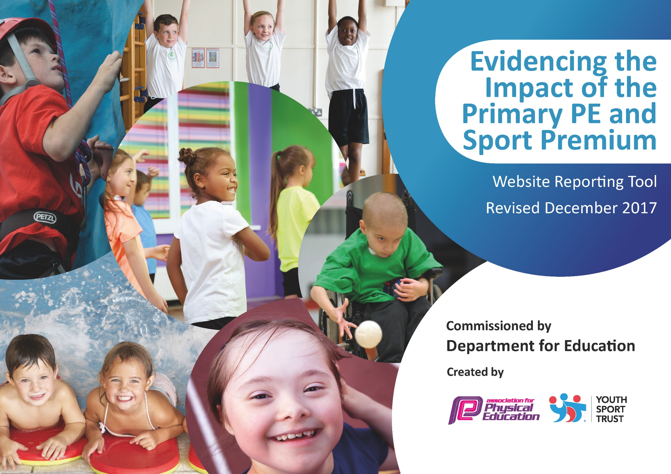

Schools must use the funding to make additional and sustainable improvements to the quality of PE and sport they offer. This means that you should use the Primary PE and Sport Premium to:

- develop or add to the PE and sport activities that your school already offers
- build capacity and capability within the school to ensure that improvements made now will benefit pupils joining the school in future years

Please visit gov.uk for the revised DfE guidance including the 5 key indicators across which schools should demonstrate an improvement. This document will help you to review your provision and to report your spend. DfE encourages schools to use this template as an effective way of meeting the reporting requirements of the Primary PE and Sport Premium.

We recommend you start by reflecting on the impact of current provision and reviewing the previous spend.
Under the Ofsted Schools Inspection Framework, inspectors will assess how effectively leaders use
the Primary PE and Sport Premium and measure its impact on outcomes for pupils, and how effectively governors hold them to account
for this.

Schools are required to publish details of how they spend this funding as well as on the impact it has on pupils’ PE
and sport participation and attainment.
We recommend regularly updating the table and
publishing it on your website as evidence
of your ongoing review into how you are using the money
to secure maximum, sustainable impact. To see an example of how to complete the table please click HERE.

Support for review and reflection - considering the 5 key indicators from DfE, what development needs are a priority for your setting and your students now and why? Use the space below to reflect on previous spend, identify current need and priorities for the future.

Key achievements to date: | Areas for further improvement and baseline evidence of need:
Fruit available to all children for break times – all of which is consumed during the week.

All children complete at least 2 hours of physical exercise in school per week.

Increase in the uptake of morning clubs.

Meeting national curriculum requirements for swimming and water safety | Please complete all of the below*:
What percentage of your current Year 6 cohort swim competently, confidently and proficiently over a distance of at least 25 metres? | 100%
What percentage of your current Year 6 cohort use a range of strokes effectively [for example, front crawl, backstroke and breaststroke]? | 100%
What percentage of your current Year 6 cohort perform safe self-rescue in different water-based situations? | 66%
Schools can choose to use the Primary PE and Sport Premium to provide additional provision for swimming but this must be for activity over and above the national curriculum requirements. Have you used it in this way? | Yes/No
*Schools may wish to provide this information in April, just before the publication deadline.

Action Plan and Budget Tracking
Capture your intended annual spend against the 5 key indicators. Clarify the success criteria and evidence of impact that you intend to measure to evaluate for students today and for the future.

Academic Year 2019/2020 | Date Updated – September 2019
Key indicator 1: The engagement of all pupils in regular physical activity – Chief Medical Officer guidelines recommend that primary school children undertake at least 30 minutes of physical activity a day in |  |  |  |  |  |  | Percentage of total allocation:
 |  |  |  |  |  |  | %
School focus with clarity on intended impact on pupils: | Actions to achieve: | Funding allocated: | 1 | 2 | 3 | Evidence and impact:
Increased activity across the school.  At least 75% of pupils access at least 3 clubs per week. | Premier Sports (NC and F) run morning clubs on a variety of sports.  Artiez runs a dance / gymnastic club in the morning.  Premier sports coach in school all day on one day a week to enable children to become more familiar with them. | £9020 |  |  |  | Only 40% of children attending the morning clubs – although children are responding well to new coach.
Key indicator 2: The profile of PE and sport being raised across the school as a tool for whole school improvement |  |  |  |  |  |  | Percentage of total allocation:
 |  |  |  |  |  |  | %
School focus with clarity on intended impact on pupils: | Actions to achieve: | Funding allocated: | 1 | 2 | 3 | Evidence and impact:
Display to show children’s achievements sporting both in and out of school.  Assemblies and show and tell time designated in celebrating sporting achievements. | A display in school dedicated to sport – showing children’s achievements and any sporting visits.  ‘Sporting star of the month’ given to a child who has shown exemplary effort in areas of sport in and out of school – including leading tasks at lunch and break times. | £0 |  |  |  | Special days display in school to show visitors and outings that are sporting related.  Show and tell is mainly based around sporting achievements, children bringing in medals and certificates of out of school activities.

Key indicator 3: Increased confidence, knowledge and skills of all staff in teaching PE and sport |  |  |  |  |  |  | Percentage of total allocation:
 |  |  |  |  |  |  | %
School focus with clarity on intended  impact on pupils: | Actions to achieve: | Funding  allocated: | 1 | 2 | 3 | Evidence and impact:
Improve the quality of teaching of sports by upskilling all staff. | Sports coach leads lessons and follows annual plan and gives school assessments. This means there is a high level of skill being taught and staff support the lesson to increase their development of the teaching of sport. | £12160 |  |  |  | Sports coach comes in weekly, shares lesson plans and assessments given at the end of each half term.
Key indicator 4: Broader experience of a range of sports and activities offered to all pupils |  |  |  |  |  |  | Percentage of total allocation:
 |  |  |  |  |  |  | %
School focus with clarity on intended  impact on pupils: | Actions to achieve: | Funding  allocated: | 1 | 2 | 3 | Evidence and impact:
Additional achievements:  To be able to offer a wider range of sporting activities so that there is a greater rate of participation both in and outside of school. | Premier Sports provide plan of activities and varied sports for children participate within during the academic year.  Fruit offered at clubs and during day.  Morning clubs provide children with the opportunity to participate in a variety of activities and changed termly. | Included in Premier Sports membership inc. £25 per entry. |  |  |  | Premier sports have long term plan covering all areas of the P.E curriculum.  Fruit is delivered on a weekly basis so that all children are encouraged to have during break times.  Morning club activities rotated every half term.
Key indicator 5: Increased participation in competitive sport |  |  |  |  |  |  | Percentage of total allocation:
 |  |  |  |  |  |  | %
School focus with clarity on intended  impact on pupils: | Actions to achieve: | Funding  allocated: | 1 | 2 | 3 | Evidence and impact:
Increased participation in competitions against other schools so that pupils have the opportunity to apply their skills. | Premier Sports  Transport to and from venues. | Included in Premier Sports membership inc. £25 per entry.  Plus refueling of mini bus from NSC C of E Primary School. |  |  |  | None as yet due to cancellation.

