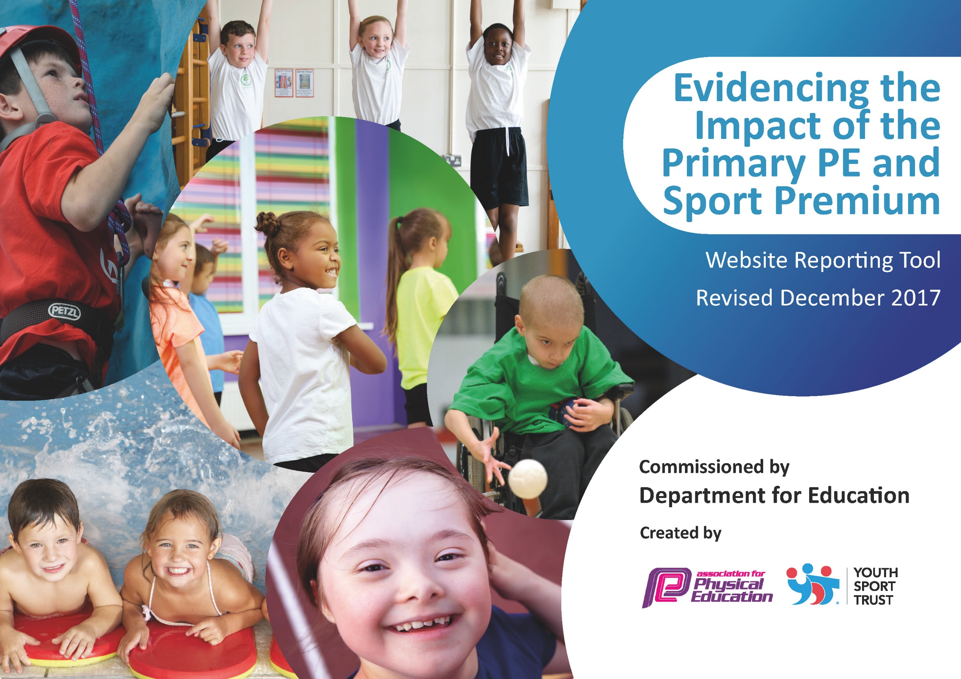

Schools must use the funding to make additional and sustainable improvements to the quality of PE and sport they offer. This means that you should use the Primary PE and Sport Premium to:

- develop or add to the PE and sport activities that your school already offers
- build capacity and capability within the school to ensure that improvements made now will benefit pupils joining the school in future years

Please visit gov.uk for the revised DfE guidance including the 5 key indicators across which schools should demonstrate an improvement. This document will help you to review your provision and to report your spend. DfE encourages schools to use this template as an effective way of meeting the reporting requirements of the Primary PE and Sport Premium.

We recommend you start by reflecting on the impact of current provision and reviewing the previous spend.
Under the Ofsted Schools Inspection Framework, inspectors will assess how effectively leaders use
the Primary PE and Sport Premium and measure its impact on outcomes for pupils, and how effectively governors hold them to account
for this.

Schools are required to publish details of how they spend this funding as well as on the impact it has on pupils’ PE
and sport participation and attainment.
We recommend regularly updating the table and
publishing it on your website as evidence
of your ongoing review into how you are using the money
to secure maximum, sustainable impact. To see an example of how to complete the table please click HERE.

Support for review and reflection - considering the 5 key indicators from DfE, what development needs are a priority for your setting and your students now and why? Use the space below to reflect on previous spend, identify current need and priorities for the future.

Key achievements to date: | Areas for further improvement and baseline evidence of need:

Meeting national curriculum requirements for swimming and water safety | Please complete all of the below*:
What percentage of your current Year 6 cohort swim competently, confidently and proficiently over a distance of at least 25 metres? | 100%
What percentage of your current Year 6 cohort use a range of strokes effectively [for example, front crawl, backstroke and breaststroke]? | 100%
What percentage of your current Year 6 cohort perform safe self-rescue in different water-based situations? | 100%
Schools can choose to use the Primary PE and Sport Premium to provide additional provision for swimming but this must be for activity over and above the national curriculum requirements. Have you used it in this way? | Yes/No  All children up to year 4 attend weekly swimming in spring term 2, any 5 and 6 children who cannot swim that statutory required distance continue to attend.
*Schools may wish to provide this information in April, just before the publication deadline.

Action Plan and Budget Tracking
Capture your intended annual spend against the 5 key indicators. Clarify the success criteria and evidence of impact that you intend to measure to evaluate for students today and for the future.

Academic Year: 2018/19 |  | Total fund allocated: £
Percentage of total allocation: | Academic Year: 2018/19 |  | Total fund allocated: £ |  |  | Date Updated: March 2019
% | Key indicator 1: The engagement of all pupils in regular physical activity – Chief Medical Officer guidelines recommend that primary school children undertake at least 30 minutes of physical activity a day in school
School focus with clarity on intended impact on pupils: |  |  |  | Funding allocated: | 1 |  | 2 | 4 |  | 6 | Evidence and impact:
Increased activity across the school.  At least 75% of pupils access at least 3 clubs per week. |  | Premier Sports (NC and F) run morning clubs on a variety of sports.  Artiez runs a dance / gymnastic club in the morning.  GTFC run football club after school.  Cleethorpes Golf Club visits school to offer taster sessions. |  |  |  |  |  |  |  |  | 26.9.18 – currently 38% attend 3 or more. 64% attend at least 1 club a week – Children enjoy sports and show increased fitness and knowledge what is involved in a healthy lifestyle.  28.11.18 40% of children attend 3 times a week (F) 8% (NC) with 64% (F) 79% (NC) attending at least 1. Some children attend the morning club as they want to not due to parental requirements.  20.3.19 – Figures are same as previous recording. Morning clubs mainly attended due to parental working needs at Fulstow. Continuity of attendance at both schools has maintained.  18.7.19 Figures same as previous – have looked at varying clubs to improve attendance next year – more children attending morning club at Fulstow.
Percentage of total allocation:
% | Key indicator 2: The profile of PE and sport being raised across the school as a tool for whole school improvement
School focus with clarity on intended impact on pupils: |  |  |  | Funding allocated: | 1 |  | 2 | 4 |  | 6 | Evidence and impact:
- Celebration assembly every term to ensure the whole school is aware of the importance of PE and Sport and to encourage all pupils to aspire to being involved in the assembles.  Role model for pupils regarding sports and fitness leads to greater participation of activities both in and outside of school.  Noticeboard to raise the profile of PE and Sport for all visitors and parents. |  | - Achievements celebrated in assembly (match results + notable achievements in lessons etc.).  Employ a Sports Coordinator to raise the profile of sport across the curriculum.  Purchase and install a new noticeboard to advertise and celebrate the sporting activities at school. |  |  |  |  |  |  |  |  | 26.8.18 – emails have been made to arrange visit from role models/professionals.  28.11.18 – Sports for Champions visited. Notice board in hall way of visitors.  Certificates of achievements and in circle time celebrate out of school sporting achievements.  18.7.19 – All children have been taught by a sports coordinator throughout the year and these have been prmoted further on displays. All achievements are celebrated in assembly.

Key indicator 3: Increased confidence, knowledge and skills of all staff in teaching PE and sport |  |  |  |  |  |  |  | Percentage of total allocation:
 |  |  |  |  |  |  |  | %
School focus with clarity on intended  impact on pupils: | Actions to achieve: | Funding  allocated: | 1 | 2 | 4 | 6 | Evidence and impact:
High quality teaching to engage the children; increasing their confidence and skills in all areas of sport. | JB Sports coach (F) Premier Sports (NC) – used to develop staff K&U of teaching sports.  CPD provided to lunchtime staff for developing playground games and activities. |  |  |  |  |  | 26.9.18 – Staff have taken some lessons following on from sessions with sports coach. Lunch times still need further development to maintain calmer periods.  28.11.18 Sports coach still being used well – area highlighted above needs work – playleaders do not attract children.  20.3.19 Sports coaches use effectively and when in aid with playtime games.
Key indicator 4: Broader experience of a range of sports and activities offered to all pupils |  |  |  |  |  |  |  | Percentage of total allocation:
 |  |  |  |  |  |  |  | %
School focus with clarity on intended  impact on pupils: | Actions to achieve: | Funding  allocated: | 1 | 2 | 4 | 6 | Evidence and impact:
Additional achievements:  To be able to offer a wider range of sporting activities so that there is a greater rate of participation both in and outside of school. | JB Sports coach (F) Premier Sports (NC)  Membership Wolds Partnership  Yoga teacher employed at both schools for one term.  Fruit offered at clubs and during day. |  |  |  |  |  | 26.9.18 – none arranged so far this term, dates are in the diary for the following term.  28.11.18 – none accessed this term due to numbers- planned for spring term.  20.3.19 – Quick sticks hockey, dodgeball and cross country offered to KS2 children this term. (cross country due to be rearranged)
Key indicator 5: Increased participation in competitive sport |  |  |  |  |  |  |  | Percentage of total allocation:
 |  |  |  |  |  |  |  | %
School focus with clarity on intended  impact on pupils: | Actions to achieve: | Funding  allocated: | 1 | 2 | 4 | 6 | Evidence and impact:
Increased participation in competitions against other schools so that pupils have the opportunity to apply their skills. | JB Sports coach  Membership Wolds Partnership  Transport to and from venues. |  |  |  |  |  | 26.9.18 – none arranged so far this term, dates are in the diary for the following term.  28.11.18 – none accessed this term due to numbers- planned for spring term.  20.3.19 – Quick sticks hockey, dodgeball and cross country offered to KS2 children this term. (cross country due to be rearranged)  18.7.19 All children have had the opportunity to participate with one or more competitions across schools.

